CI and CD extra

Run and Release Retention Policy

1. Whenever we are executing the build which is called as Run and whenever if you are executing the Release Pipeline it called release

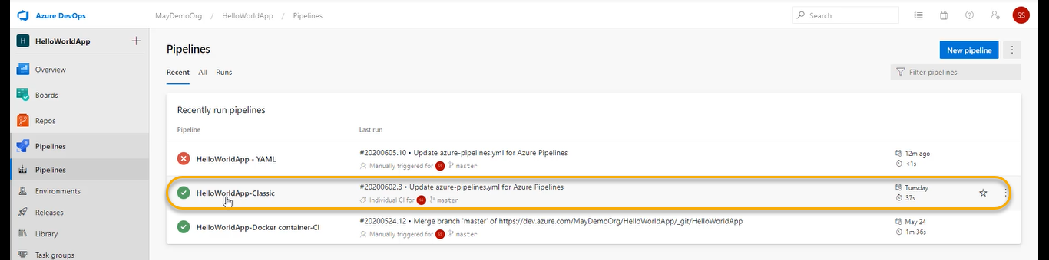

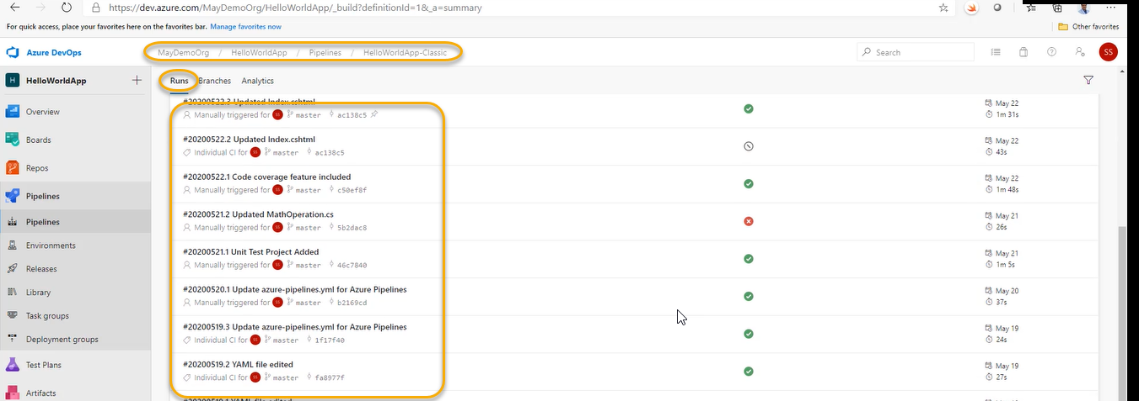

From the begging all the Runs are stored

And for every Run we have all the logs

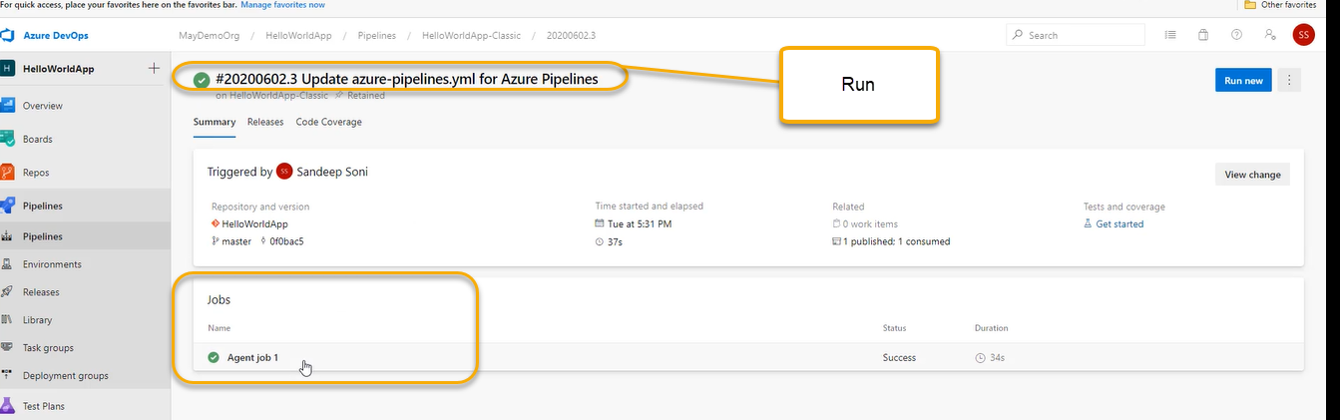

Click on the Agent job 1

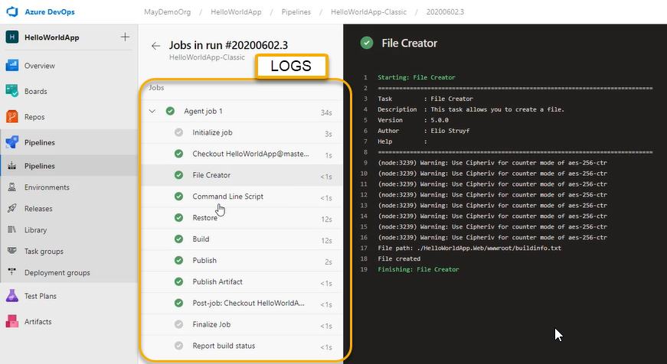

These are all (logs) taking space

So at some point we are delete them. Because we have cost for storage

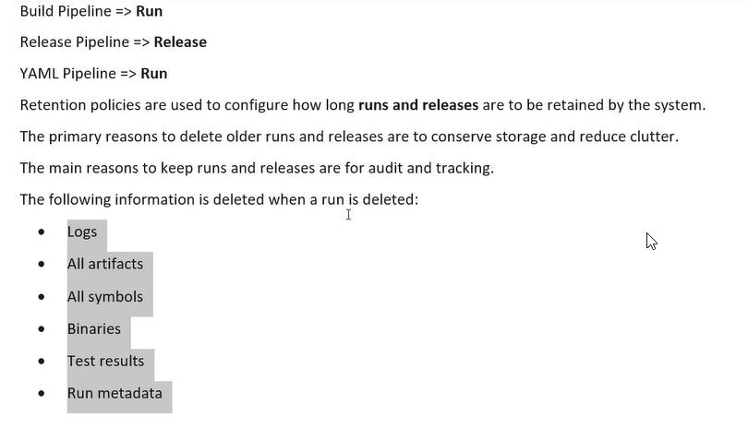

If my prod server crashes we can go to release and Re-Run it

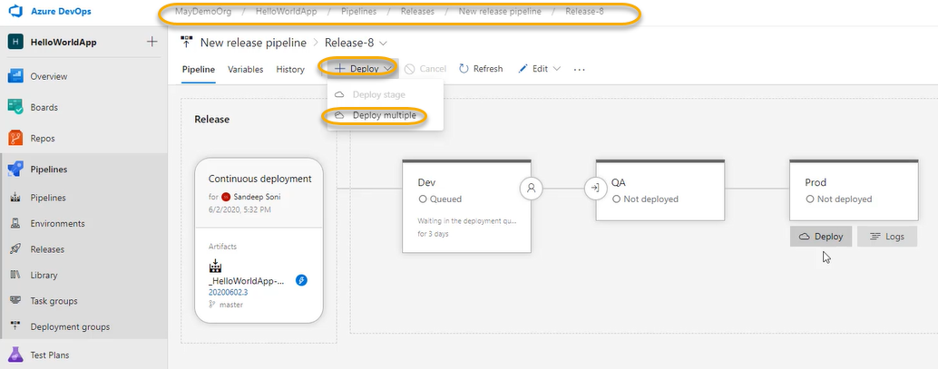

So, it will gain run on Dev > QA > Prod

Releases will automatically take from Artifact

There are already retention policies set

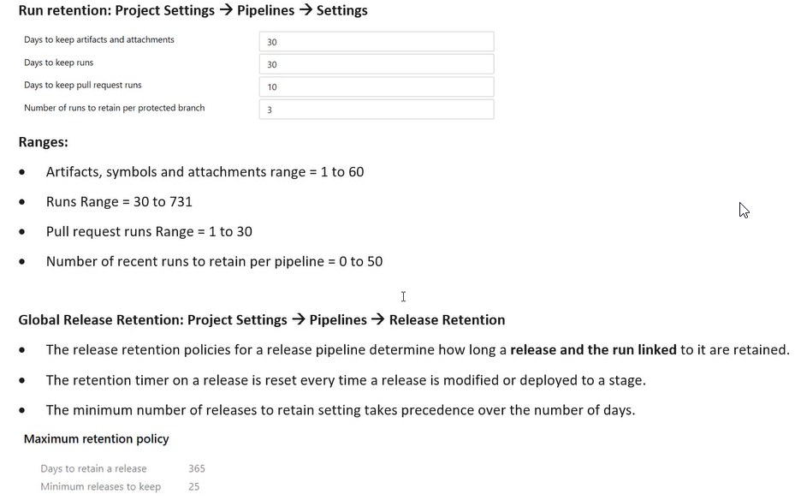

We can change the retention policy on a need basics

Run Retention policies

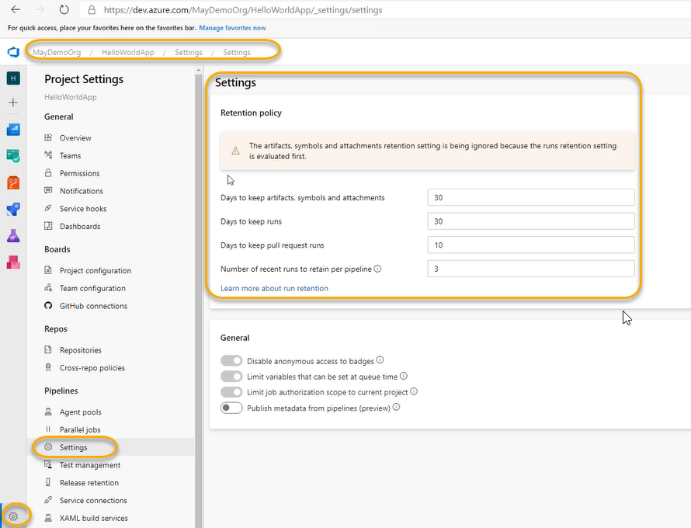

Number of recent runs to retain per pipeline is 3(last three runs will be retained even after Runs are deleted)

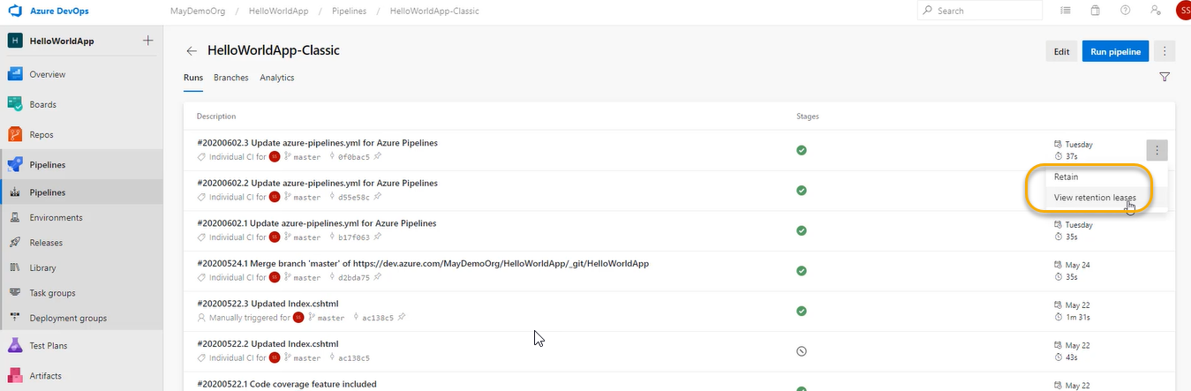

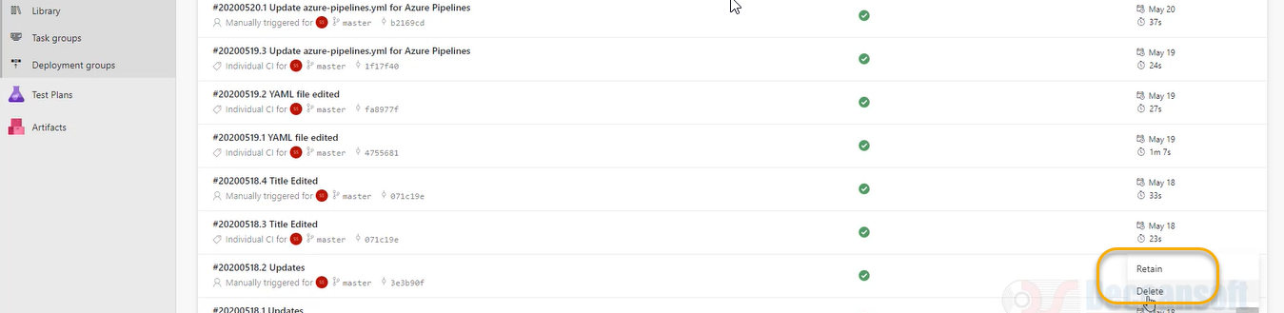

Some of the Runs I am able to delete and some of them I unable to delete ((top 3) Runs the particular Run has been leased

The artifact of this particular Run has been used in release the artifact which is the output of the particular Run has been used in the Release

Since Artifact is used in the release ( and it can be used to Redeploy)

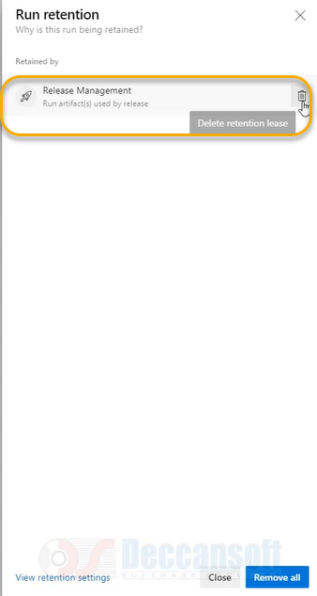

Now we can see the option to delete

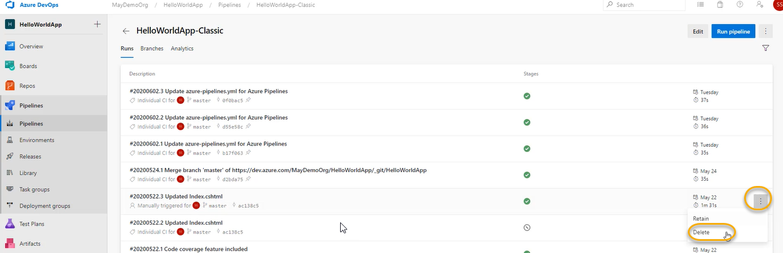

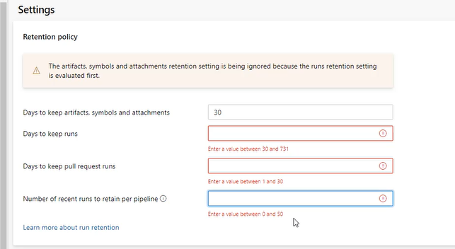

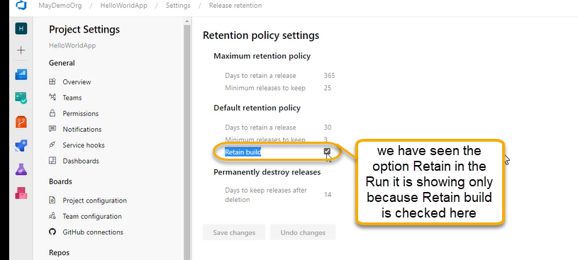

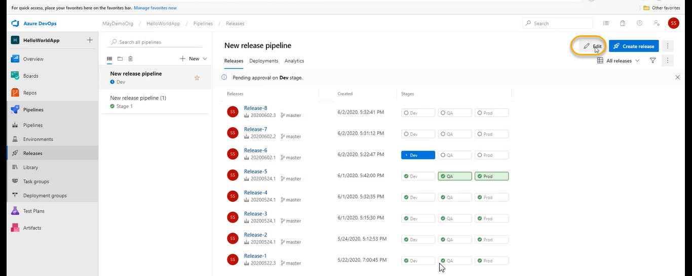

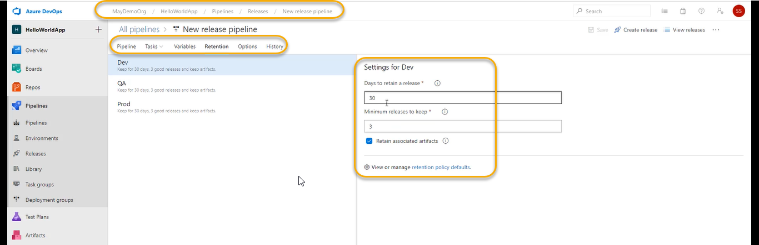

And the above settings we can do each one of the stages like QA and Prod

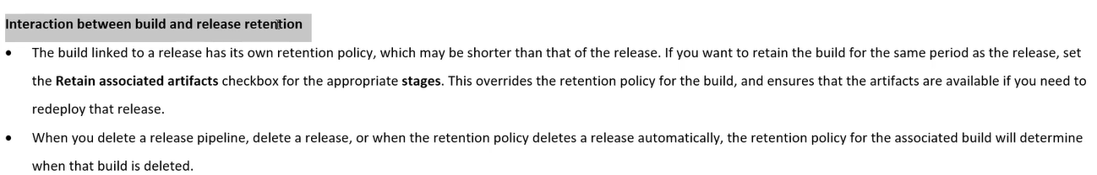

We are unable to delete the build because there is a release associated to it

6-Manage Pipeline Resources Permissions

1. When we will create a pipeline it will require some resources

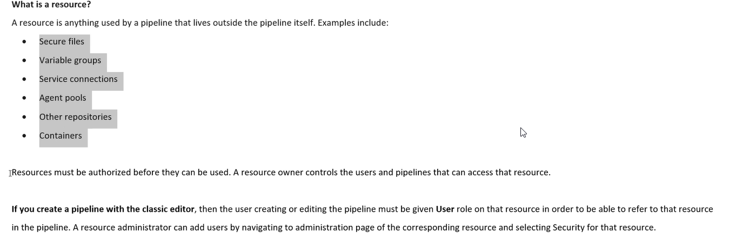

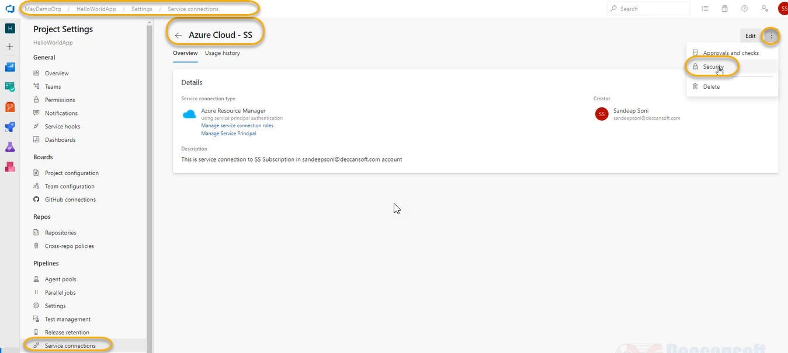

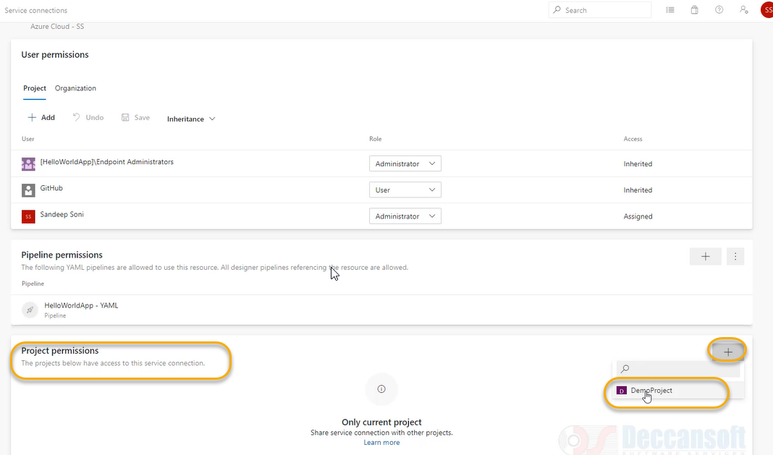

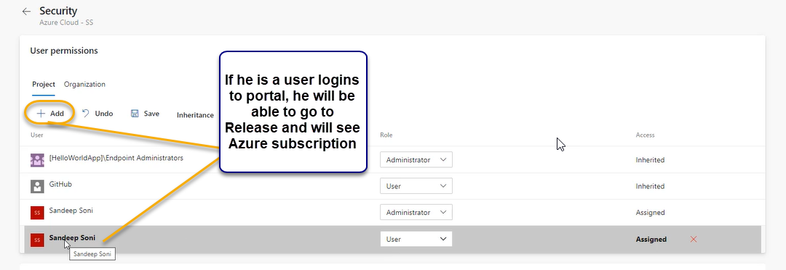

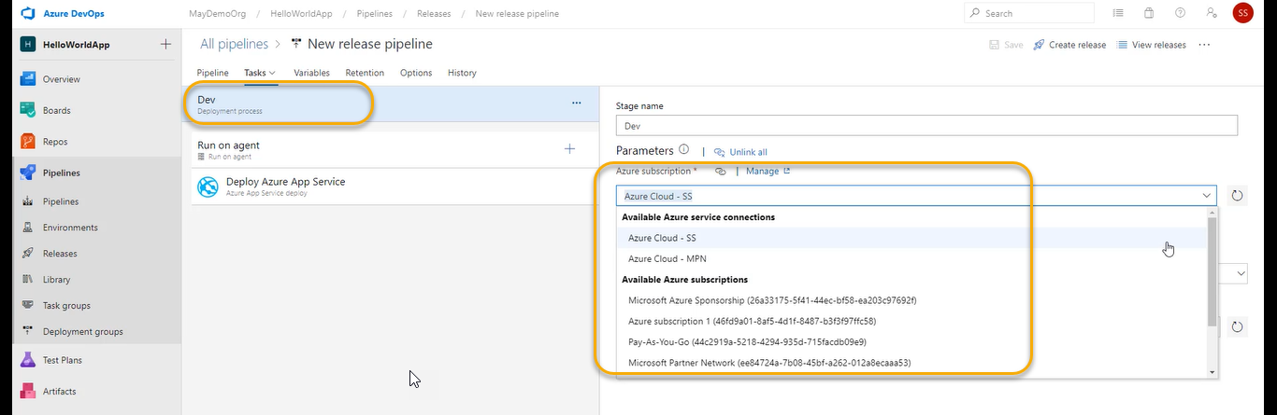

And he changes the Azure subscription (User)

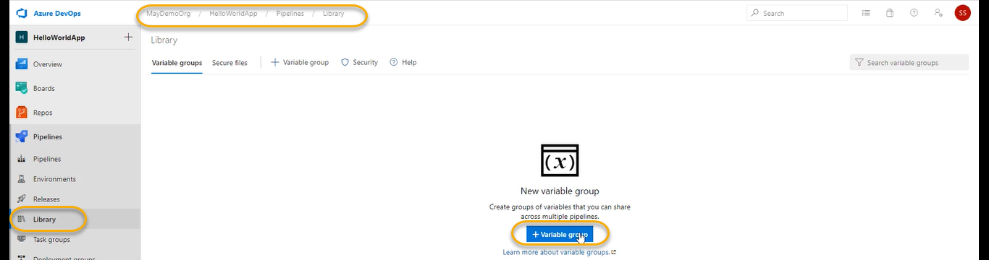

For the YAML

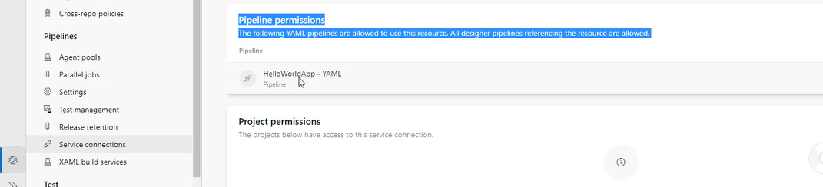

YAML pipelines if they want to use resources the pipeline should give permission

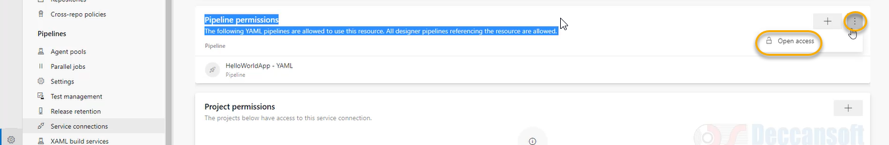

You can authorize all pipelines now

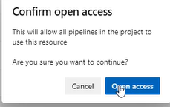

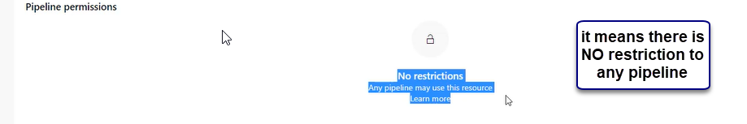

All pipelines can use the below resource

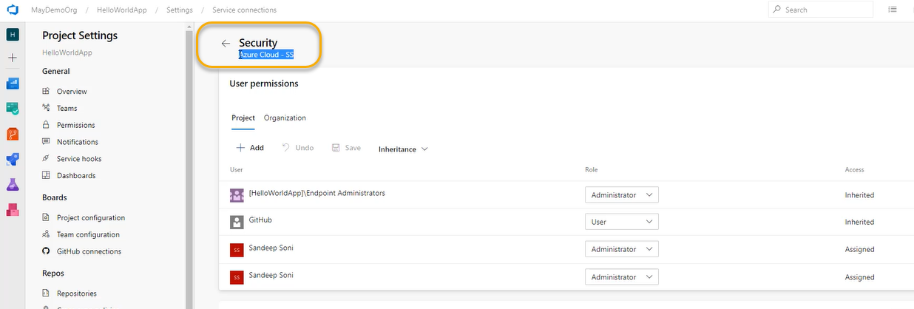

If you are creating the pipeline for the first time

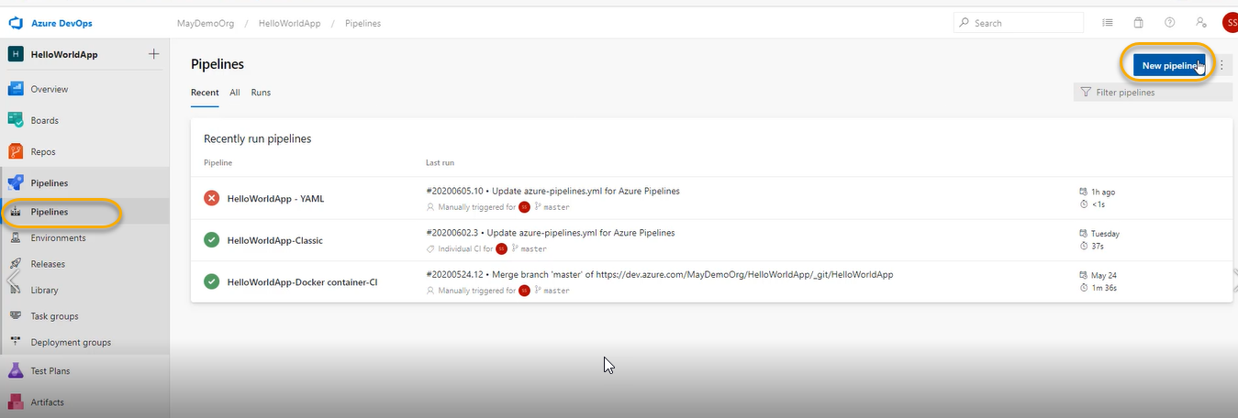

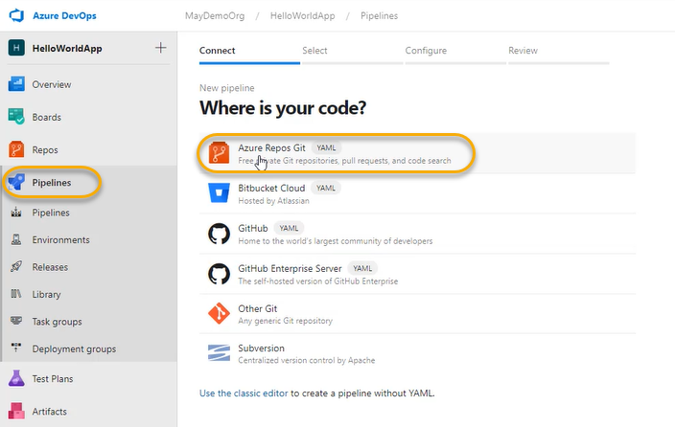

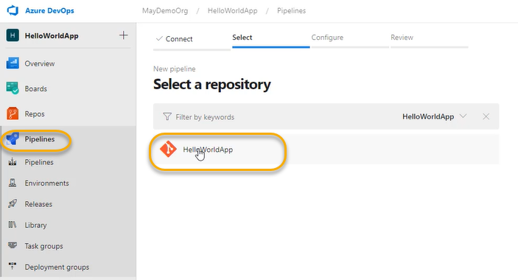

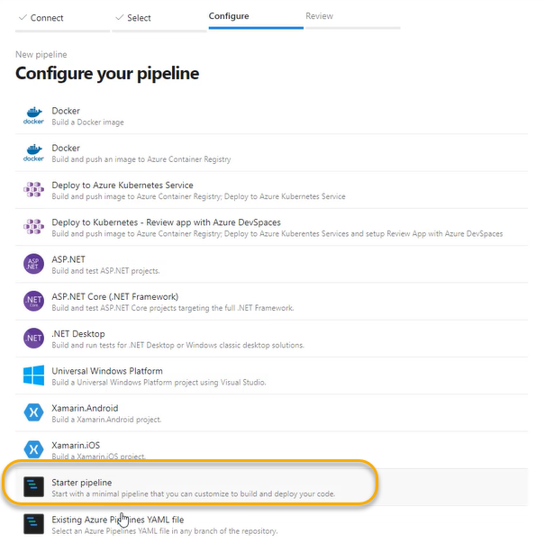

When we are adding a task

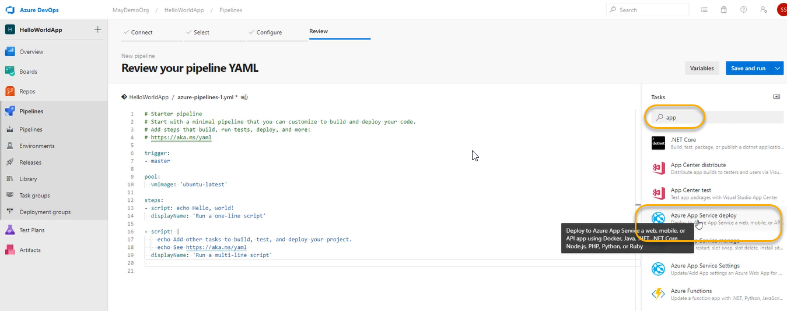

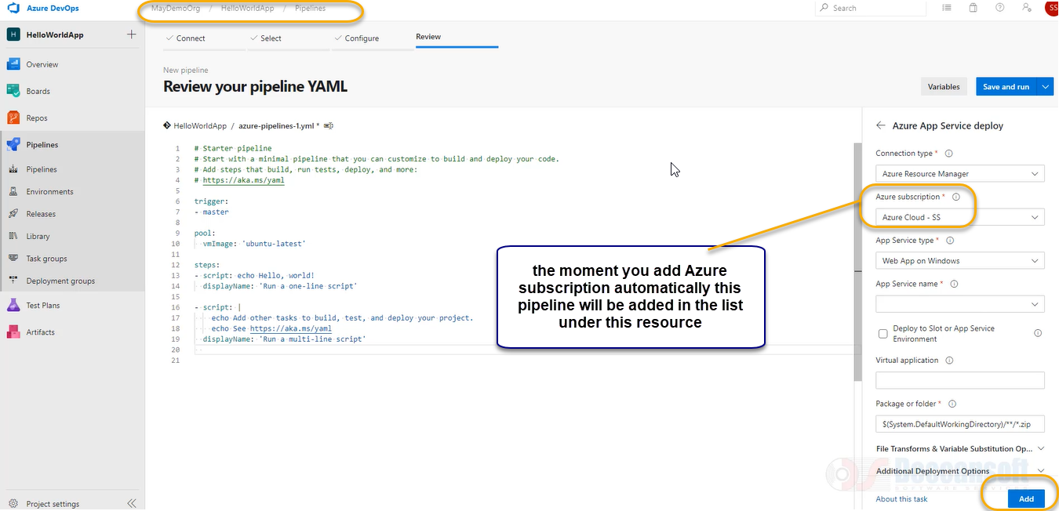

Intentionally delete the script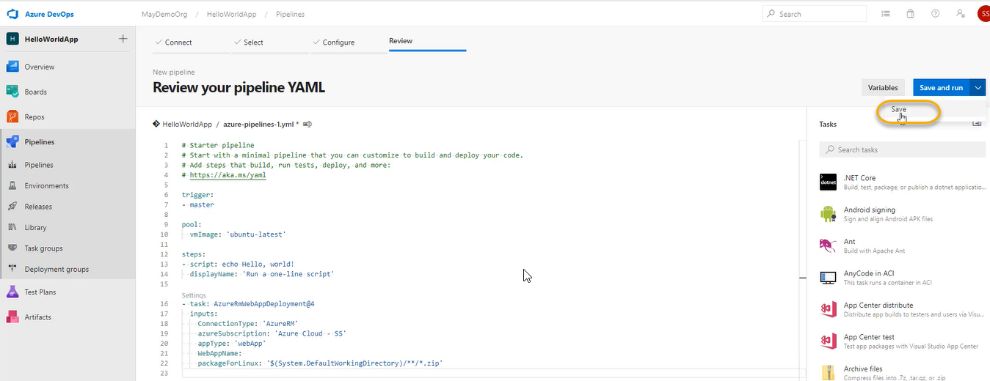

A pop will come and again click on save

Now you will this YAML file will be visible under the Azure SS subscription

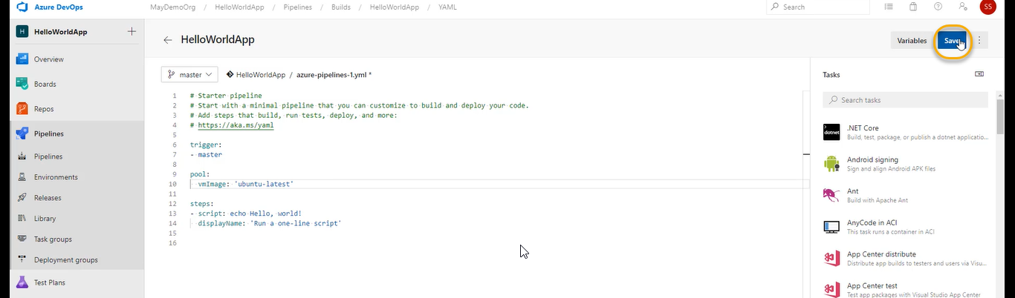

A pop will come and click on save

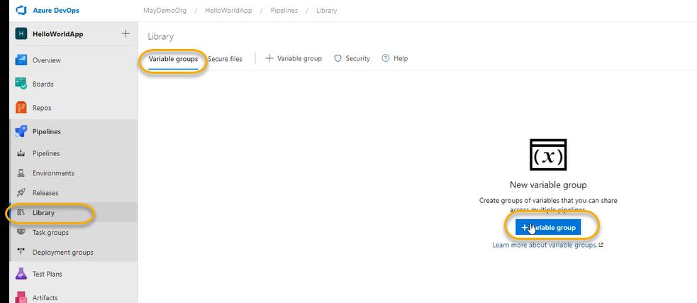

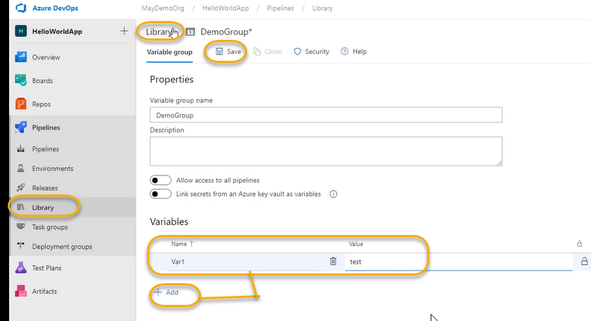

Now edit the YAML file and save and save and Run

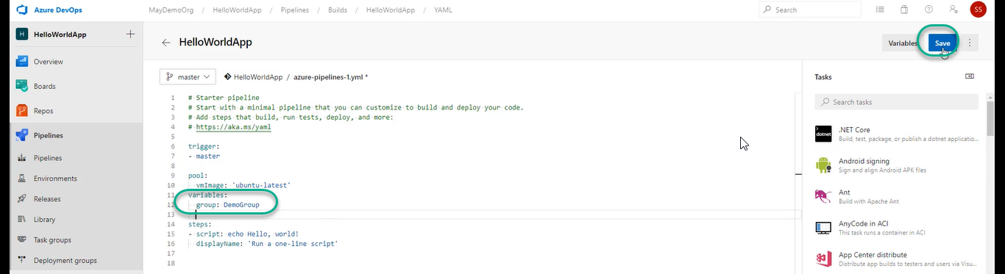

And Again Run

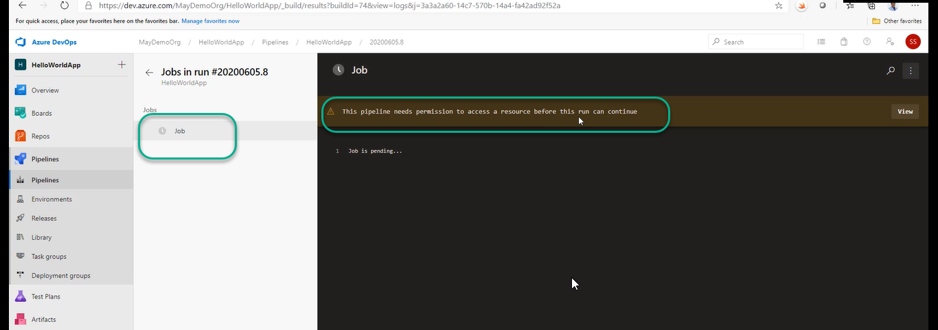

Pipeline is already there after that I have created the Resource (Variable group)and then added to the pipeline

Click on the View as shown in the above screenshot

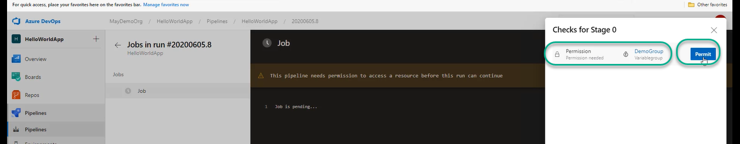

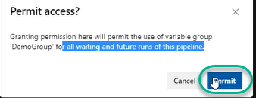

And next time onwards if you Run it will not Ask you

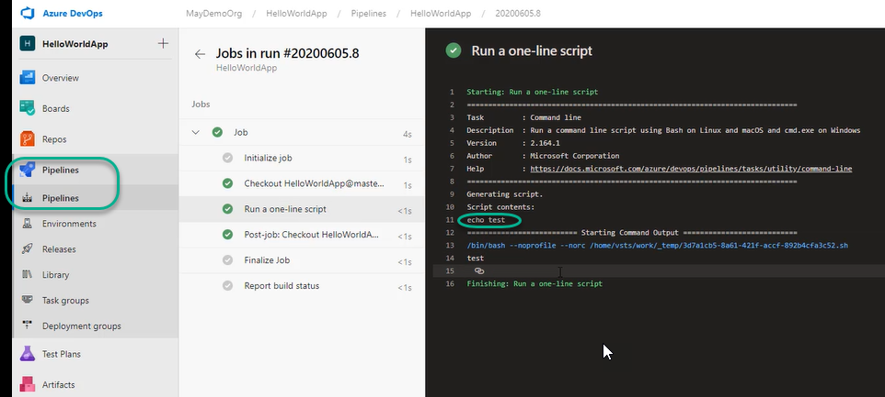

7-Deep Dive into Jobs

1. For every Job we have a separate agent

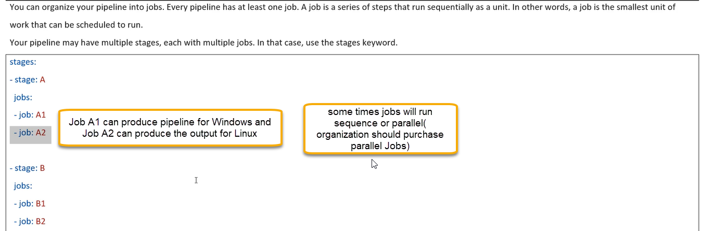

There are three types of Jobs: A job in which agent is associated and A job which is referred as deployment job and a job will run at multiple targets at a time

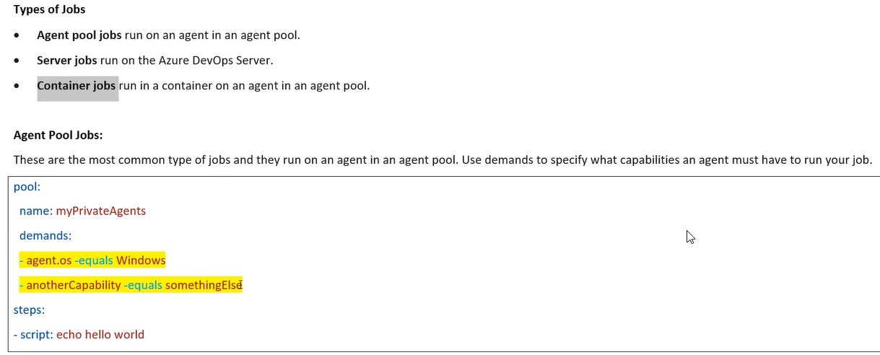

Below is the server jobs or agent less job

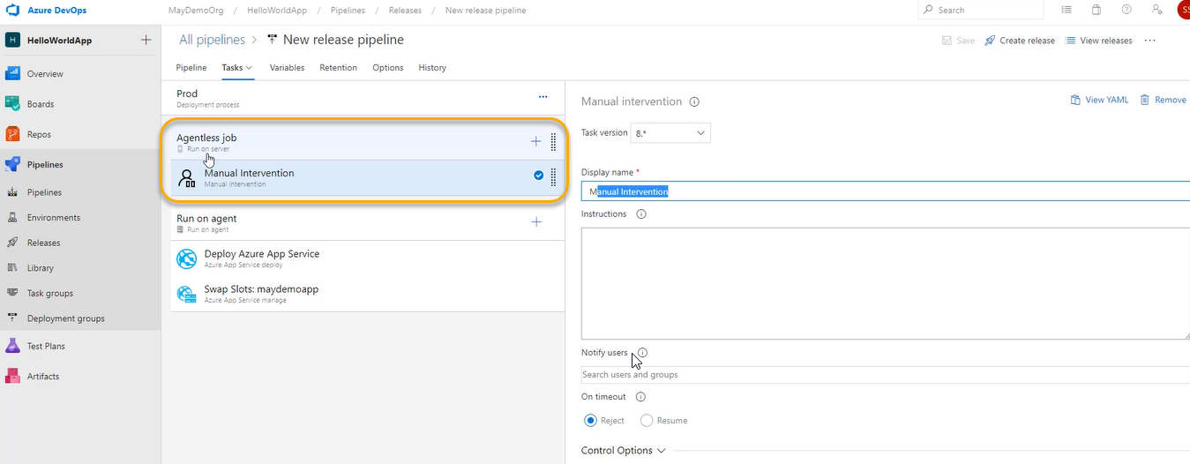

Container Jobs

If I have a requirement of certain software to be used at the time of performing the build on my machine

But at the same time I don’t want to install the software on that machine physical or VM I don’t want to permanent installed

I will first create a container image and I will put all my software at container image and thereafter I will tell the Run Time to use the container that image it can be custom image so from there it will download the container image execute the pipeline in that particular image and make use of all software which are installed through that image in that container and done

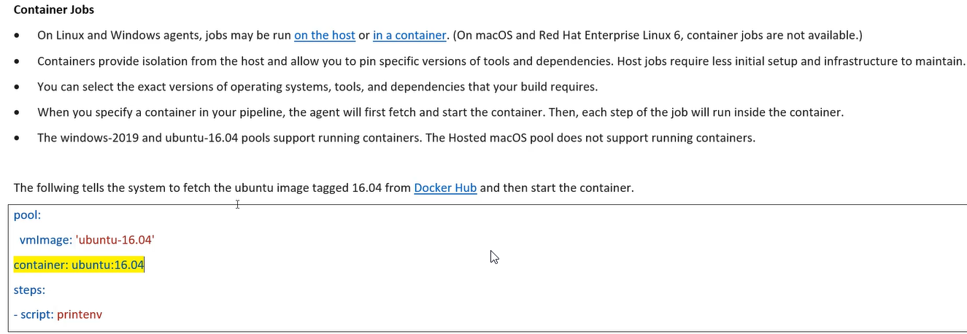

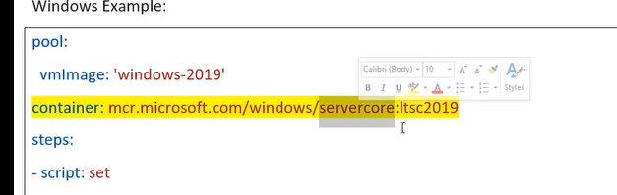

Job Workspace

When ever a job is executing on a agent it is going to use certain directories

Once the agent is completed in executing the pipeline what will happen to these directories

That we can control through workspace

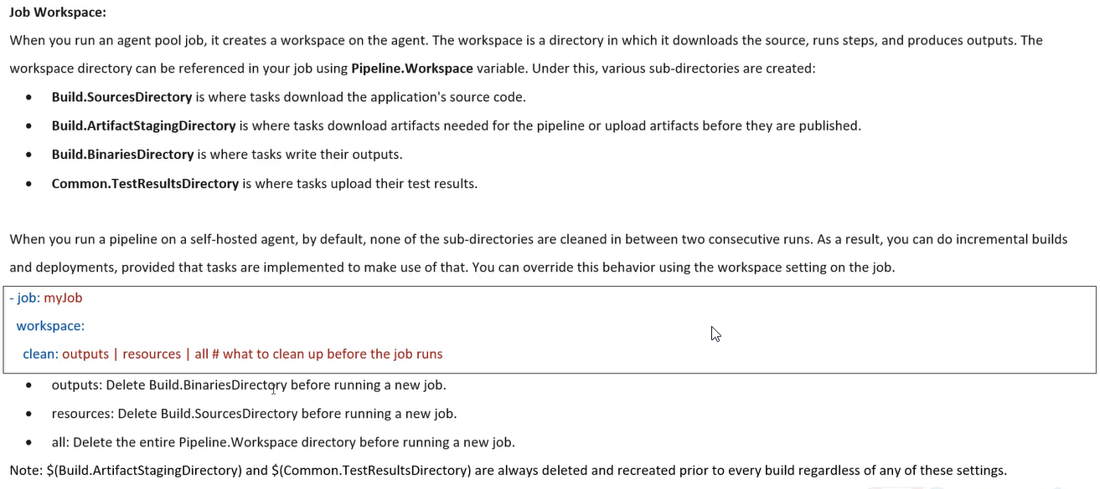

8- About DevOps Libraries

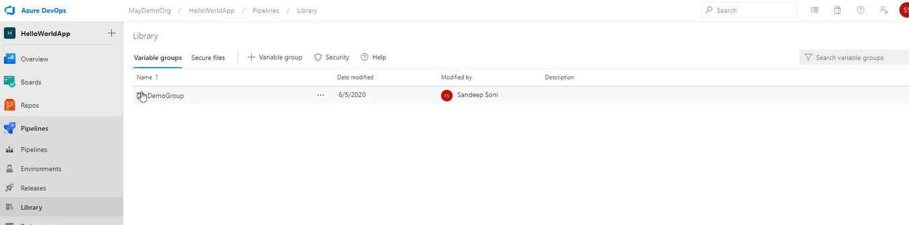

Variable group is a collection of variables which I want to use it across multiple pipeline

Variable group for every resource we can give permission only the users listed below can use the variables in the pipeline

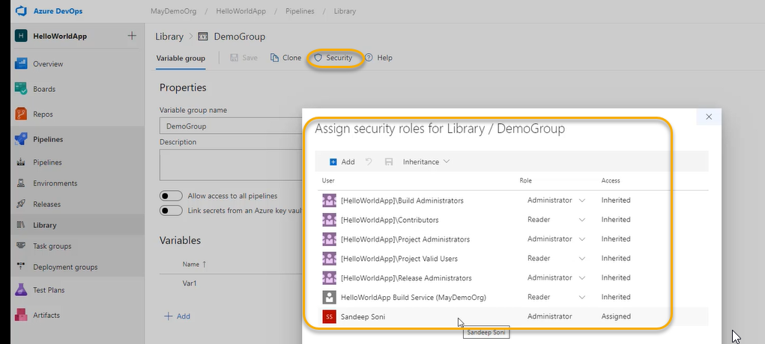

If you create the variable group, we can always lock it

It will only print \*\*\* values NOT the Actual Values

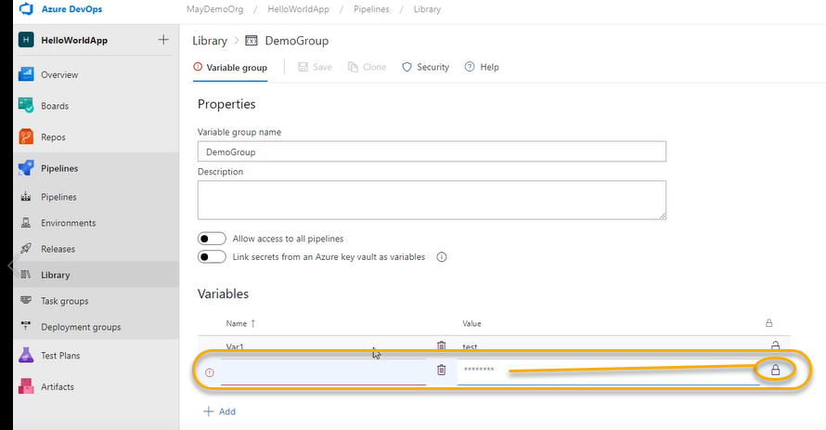

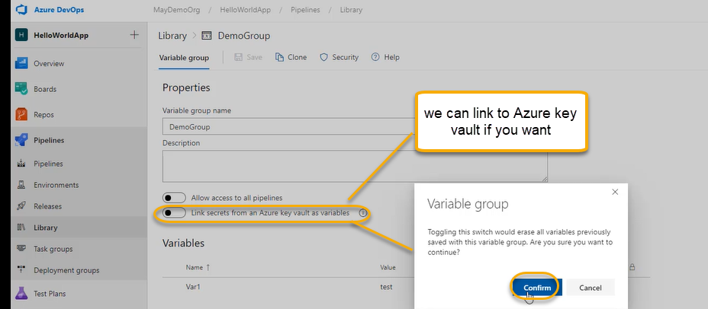

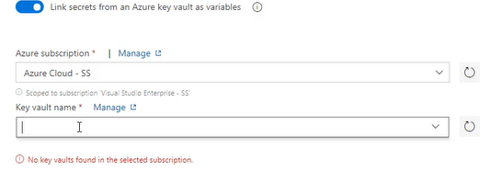

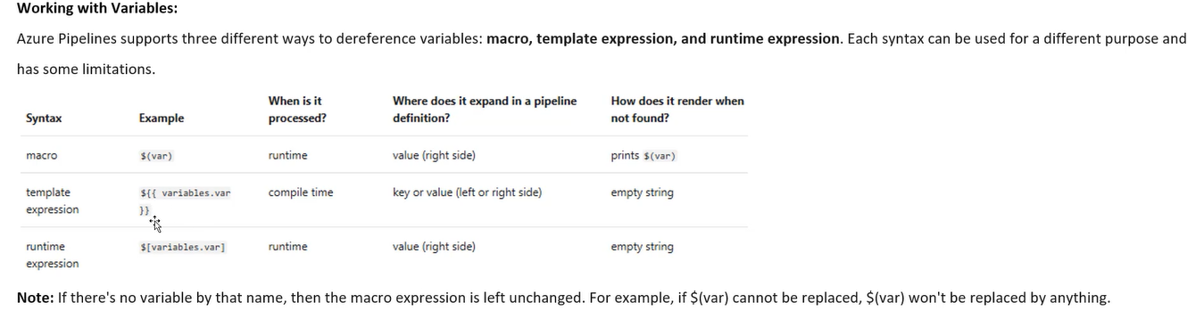

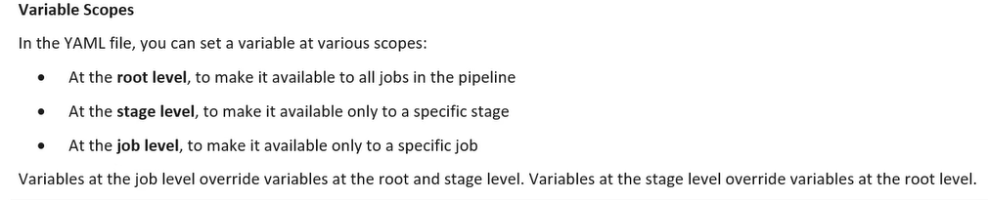

For Classic

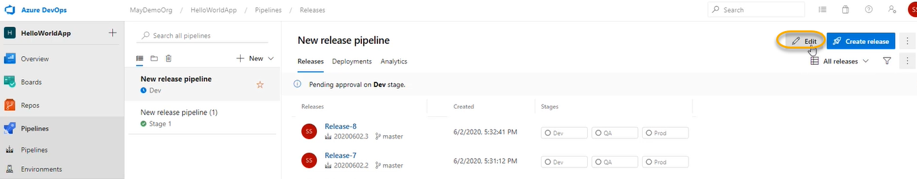

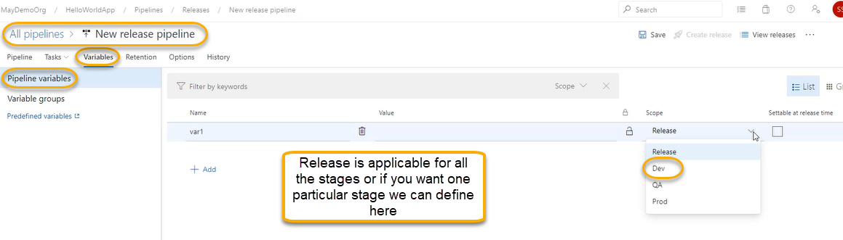

Set secret variables in YAML

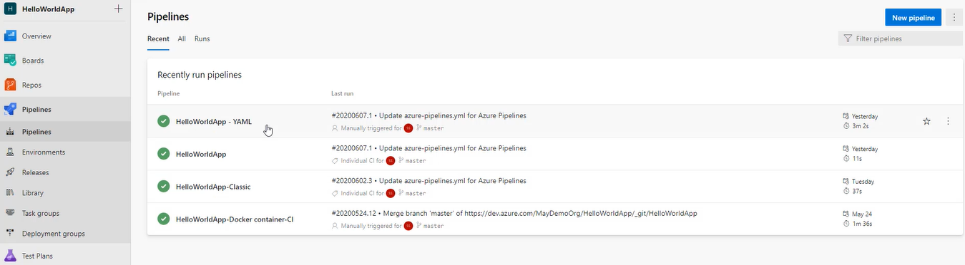

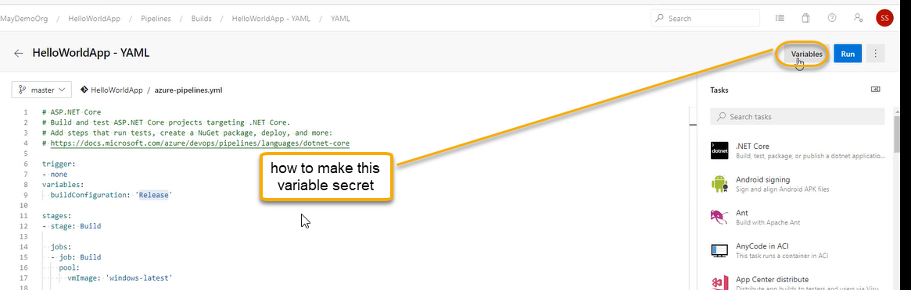

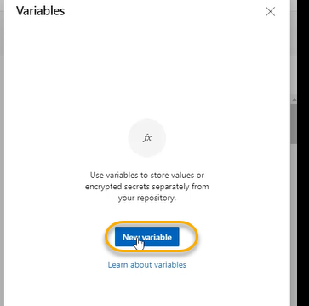

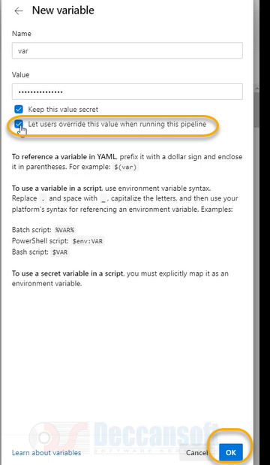

A pop will come and again click on save

Lets user override the value Now if you Run the pipeline it will give the option of variables whether users need to override the variables are NOT

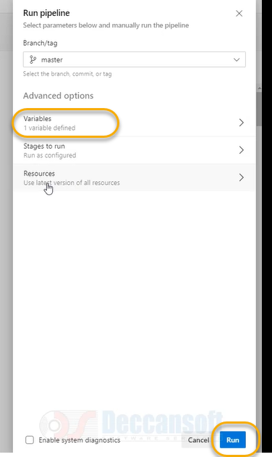

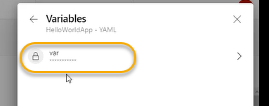

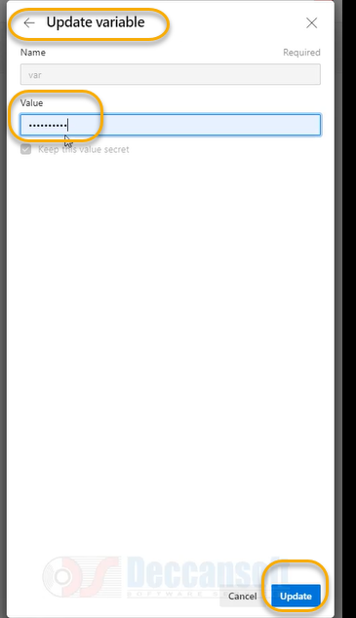

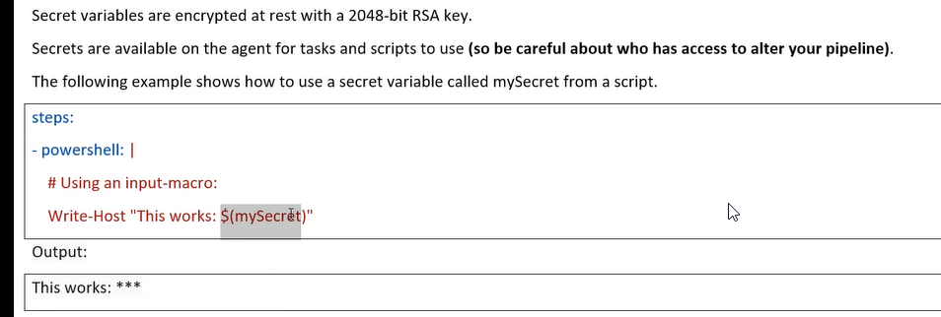

<https://docs.microsoft.com/en-us/azure/devops/pipelines/build/variables>

secure Files

we will place all files in Rep and whenever we needed, we will take it from Repo

if you think it is NOT secure to place the files in Repo and the files will be available only at pipeline NOT for developers

so add the files in the below location

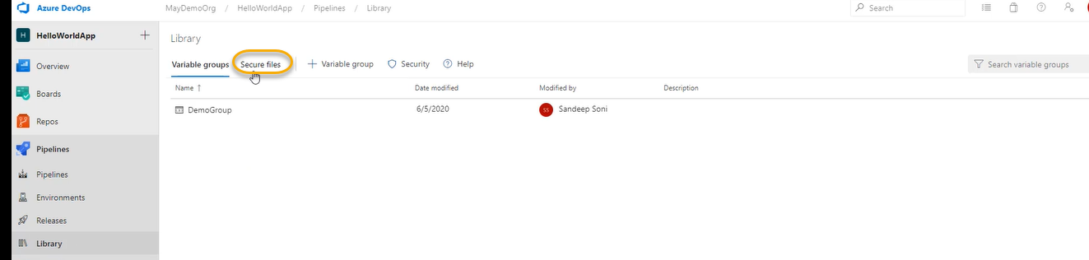

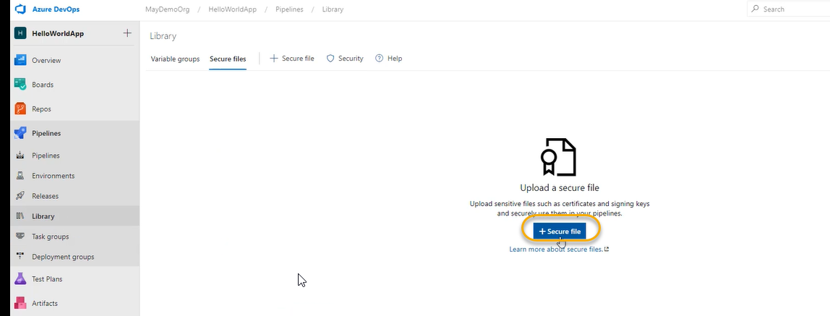

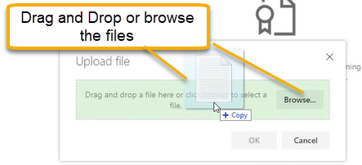

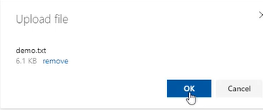

9-Pipeline Conditions

1. Condition can be specified at stage level/job level most of the time we will mention at Job level only

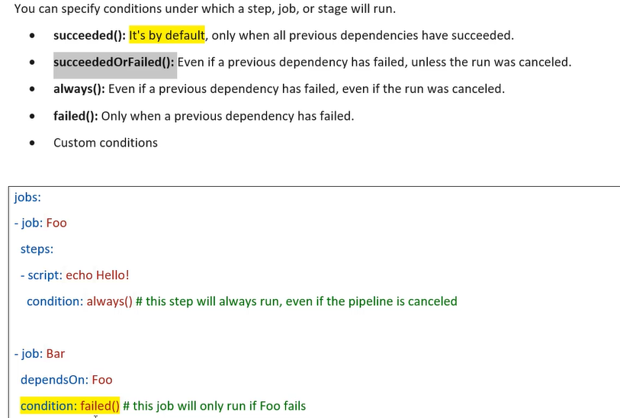

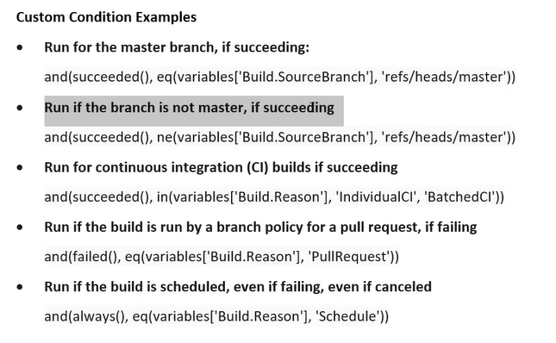

eq – equals to , ne-not equals to, in -in

we will have one pipeline for Dev, QA and Prod and we have Development and Master branches. When the changes done to development branch then deployment must be happened in Dev after that QA and for Prod deployment, we need to have a change done in Master branch we can use the above custom condition

